leah.a

[Company name]  [Company address]

[Document title]

**Logic Design (ITNT202)**

**Assignment No. 1**

|  |  |  |  |
| --- | --- | --- | --- |
| **Student Name:** |  | **Last date of Submission:** |  |
| **Student ID:** |  | **Marks:** | **10** |

Problem 1: Convert the following number system. *Show your solution.*

1. Addition of Binary Numbers
   1. 10101112 add to 11111112 is equal to 🡪

(011010110)2

1. Subtraction of Binary Numbers

111000102 subtract to 10111112 🡪 (10000011)2

III: Find the output of following logic circuit

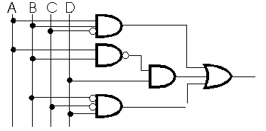

$$AB\vec{C}+\vec{AB}D+\vec{B}\vec{C}D$$

IV: Draw the Logic circuit for the following Boolean expression



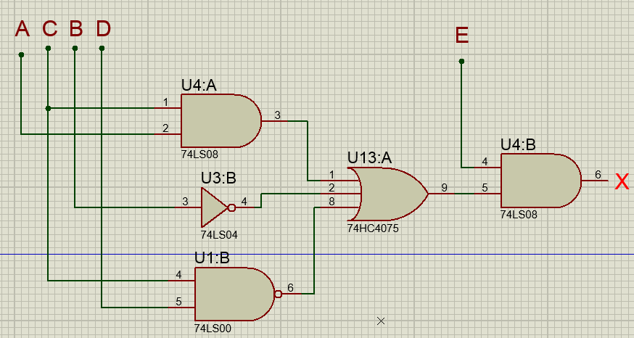

V: Find the Boolean expression for the following truth table (SOP form).

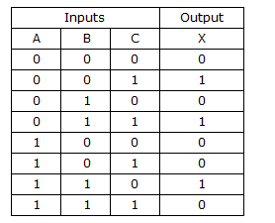

$$\vec{A}\vec{B}C+\vec{A}BC+AB\vec{C}$$

VI: Simplify the following Boolean expression using Boolean algebra.

$\vec{A}BC+ABC+A\vec{B}\vec{C}+A\vec{B}C +\vec{A}\vec{B}\vec{C}$****

------rearranging terms

BC($\vec{A}$ +A) + $A\vec{B}(C+\vec{C})$ + $\vec{A}\vec{B}\vec{C}$

As we kow that A+ $\vec{A}$ =1 and C+ $\vec{C}$ =1

BC(1)+ $A\vec{B}(\left(1\right)+$ $\vec{A}\vec{B}\vec{C}$

BC+ $A\vec{B}$ + $\vec{A}\vec{B}\vec{C}$

BC+ $\vec{B}(A$ + $\vec{A}\vec{C}$)

As we know that $A$ + $\vec{A}\vec{C}$ =A+ $\vec{C}$

BC+ $\vec{B}($ A+ $\vec{C})$

BC+ $A\vec{B}$ + $\vec{B}\vec{C}$

VII: Use the K-Map to simplify the following standard SOP expression.



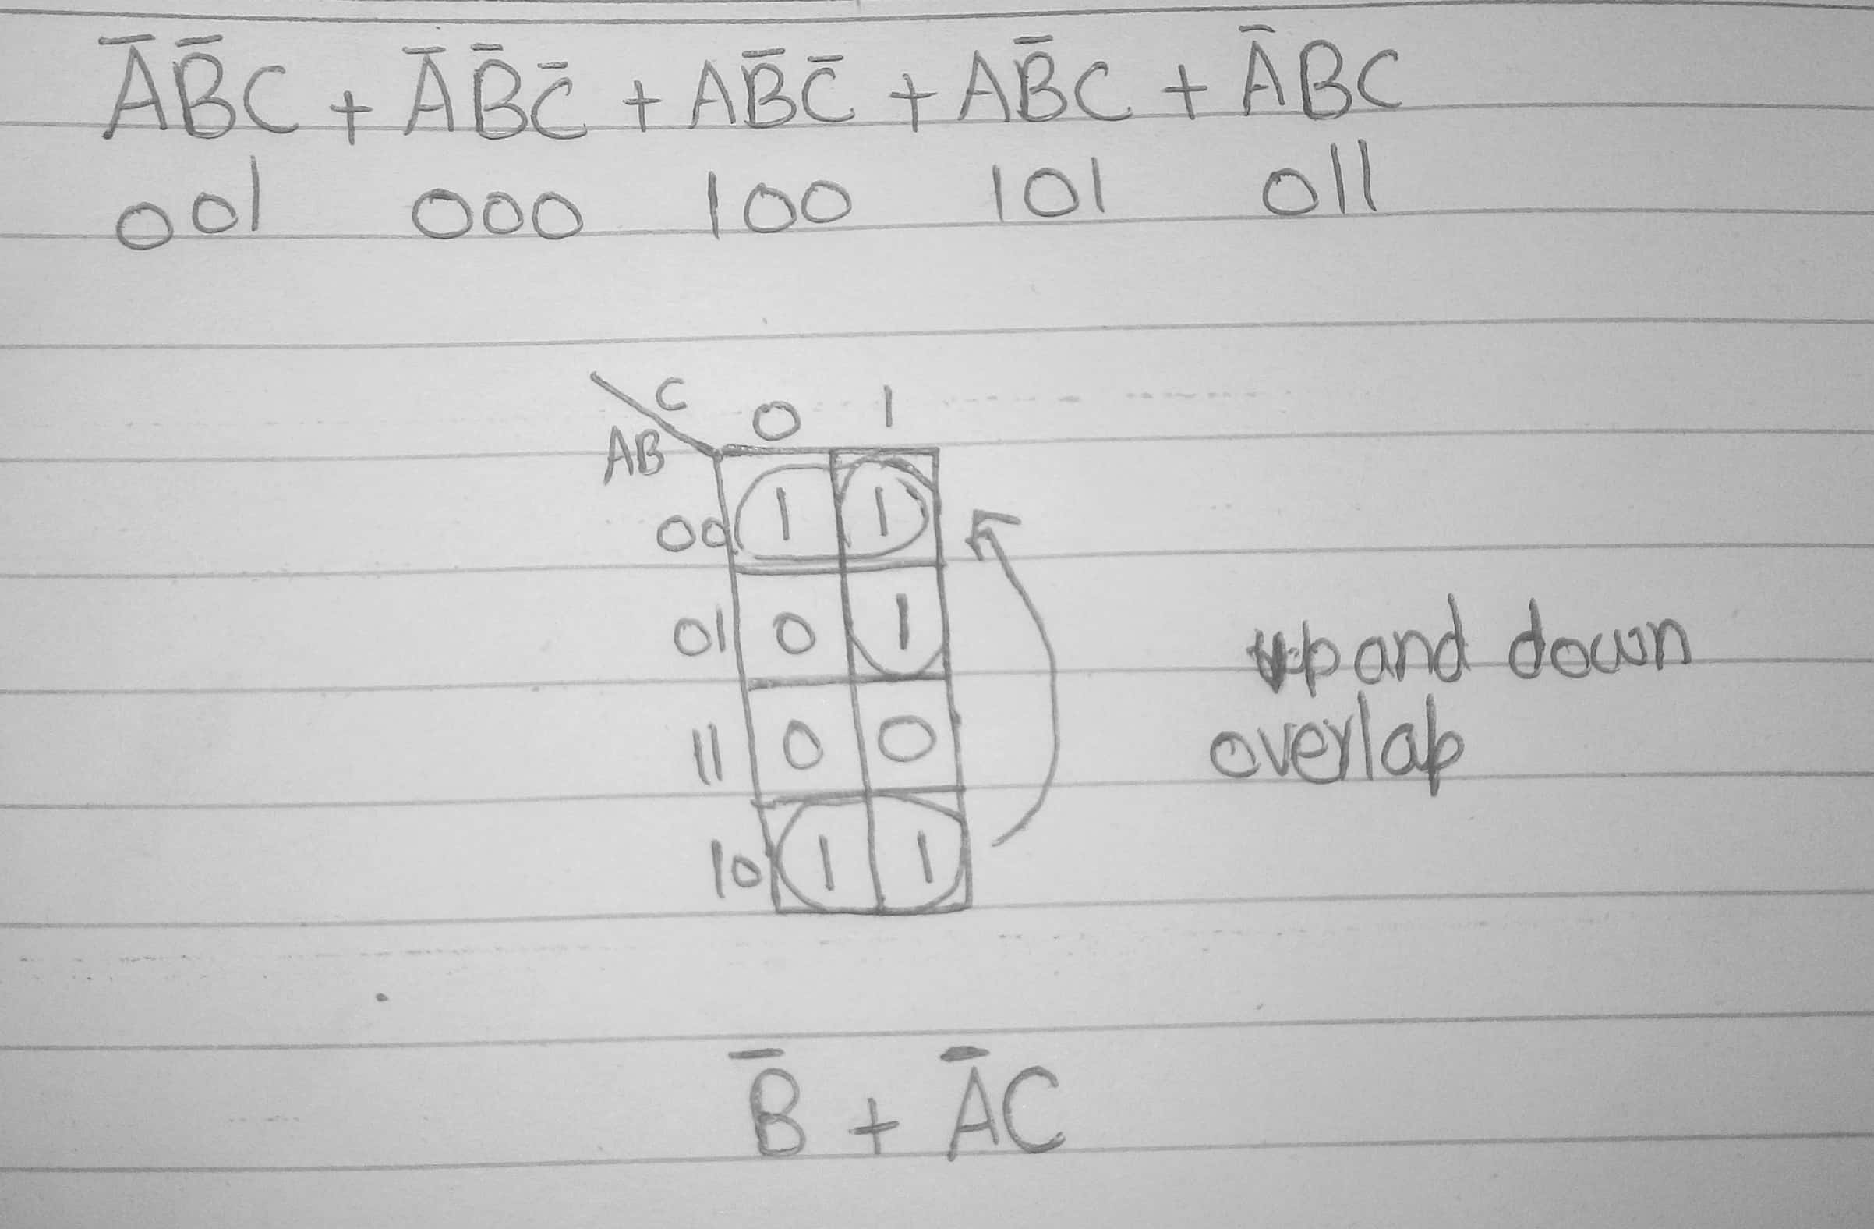

VIII. Analyze the given truth table to find out the simplified Boolean expression using K-Map SOP method. Write down the number of AND gates and OR gates used in the simplified circuit.

a) Finding of SOP Expression

b) K-Map Entry

c) Find the Simplified expression

d) Draw the logic circuit of the simplified expression

e) Identify the number of gates used

|  |  |  |  |  |
| --- | --- | --- | --- | --- |
| **Input** | | | | **Output** |
| **A** | **B** | **C** | **D** | **F(A,B,C,D)** |
| **0** | **0** | **0** | **0** | **1** |
| **0** | **0** | **0** | **1** | **1** |
| **0** | **0** | **1** | **0** | **0** |
| **0** | **0** | **1** | **1** | **1** |
| **0** | **1** | **0** | **0** | **0** |
| **0** | **1** | **0** | **1** | **1** |
| **0** | **1** | **1** | **0** | **0** |
| **0** | **1** | **1** | **1** | **1** |
| **1** | **0** | **0** | **0** | **0** |
| **1** | **0** | **0** | **1** | **1** |
| **1** | **0** | **1** | **0** | **1** |
| **1** | **0** | **1** | **1** | **1** |
| **1** | **1** | **0** | **0** | **1** |
| **1** | **1** | **0** | **1** | **1** |
| **1** | **1** | **1** | **0** | **0** |
| **1** | **1** | **1** | **1** | **1** |

